

**Asia Pacific College**

**School of Computing and Information Technologies**

**Introduction to Systems and Design**

**J.I.T (Just in Time) Ordering System**

Lance Gabriel Villaluz

John Dave Salcedo

Alfredo Tobias

Timoteo Aricayos

**TABLE OF CONTENTS**

1. [**Introduction**](http://projects2.apc.edu.ph/wiki/index.php/Inventory_System#I.__Introduction)**……………………………………………………………………………..3**

**1.1 Project Context……………………………………………………………………..3**

**1.2 Purpose and Description…………………………………………………………...4**

**1.3 Objectives…………………………………………………………………………....4**

**1.4 Scope and Limitations………………………………………………………………4**

1. [**Review of Related Literature/Systems**](http://projects2.apc.edu.ph/wiki/index.php/Inventory_System#II.___Review_of_Related_Literature.2FSystems)**…………………………………………………5**
2. **List of Diagrams……………………………………………………………………….…7**

**3.1 Event Table…………………………………………………………………………...7**

**3.2 Use Case Diagram…………………………………………………………………....8**

**3.3 Use Case Full Description…………………………………………………………...9**

**3.4 Functional Decomposition Diagram.……...……………………..………………...12**

**3.5 Context Diagram………….………………………………………………………...13**

**3.6 Data Flow Diagram Level.…………………………………………………………14**

**3.7 Activity Diagram.…………………………………………………………...............16**

**3.8 Sequence Diagram………….……………………………………………………....17**

**3.9 Entity Relationship Diagram…………………………………………………...….18**

**3.10 Data Dictionary……………………………………………………………………20**

* 1. **Introduction**
  2. **Project Context**

Online ordering is a wonderful way for business to increase their sales and provide better customer support and engagement. M.C. Manabat is a sole proprietorship business that sells computer, monitors, and computer parts. The business adapts the JIT (Just In Time) approach to lessen their inventory cost. The client didn’t have a system and they use mobile phones when ordering and receiving orders from customers.

The business encountered many problems for not having a system such as time-consuming process, inaccurate reports, unorganized business, and misunderstanding between the client and the customer. There is some instance that can interrupt mobile conversation, the client didn’t want to rely on mobile phones. The team will develop a web based application, so the client and the customer will have access anytime and anywhere. The system will provide: (1) an organized business (2) accurate reports (3) large volume of online orders (4) effective online ordering. With this proposal, the team expect to improve the client’s business.

* 1. **Purpose and Description**

The purpose of this project is to improve the ordering process of the client’s business and improve the operation of the company. It helps to generate reports accurately, enhance productivity, and effective online ordering.

It will also help the customer in ordering and have the visibility of the items available and the system can also eliminate redundant work like checking the availability of the item through phone call, and avoiding miscommunication or missed requests.

* 1. **Objectives**
* To increase efficiency and improve services provided to the customers through better application of technology in daily operations
* To improve the service, sales, and customer satisfaction
* To have a convenient way to order of items.
* To create a web based application that is easy to use.
  1. **Scope and Limitations**

The system will provide a web based application using PHP. It aims to improve the efficiency of ordering process for customer and provides accurate reports. Customers will be able to view the product, price, and description visually. There will be 2 users for the system, the customer, and the logistics. The user requires a computer and internet connection to use the system.

* 1. **REVIEW OF RELATED LITERATURE**

**Toyota Inventory Management**

Toyota’s system is the “Kanban System”, kanban is a just-in-time method of inventory control, that originally developed in Japanese automobile factories. Kanban method is used by Toyota Corporation it provides quick and precise information and quick response to changes. It maintains full control of the inventories and minimizes waste. https://www.linkedin.com/pulse/inventory-control-toyota-production-system-kanban-case-arvind-sharma

**HP (Hewlett-Packard)**

HP is the one of the largest PC manufacturer, one of the problems of HP is lack of visibility because of high inventory costs.. It’s a problem that affects companies large or small. HP adjustment to reduce the cost of inventory to its net realizable value are made by solving their inventory issues by using just-in-time (JIT) system.

Wagner, C. (2017, May 17). Inventory Management: A Lesson From Hewlett-Packard (HP). Retrieved August 27, 2017, from http://blog.qad.com/2017/05/inventory-lesson-hp/

**Dell**

Dell, the second-largest PC seller behind Hewlett-Packard Co., only builds computers that have already been ordered. Customers make their purchases through Dell's Web site, phone banks and corporate sales force. Based on those orders, Dell gives itself three days maximum to build the computers. Dell's computers keep track of what components customers have ordered for their machines.

If the company receives orders for an unusually large number of a component, such as a certain kind of Pentium 4 chip, Dell goes on red alert, rushing to wring out emergency shipments from suppliers.

Harrison, C. (2002, July 29). Dell Manufactures Success With Just-In-Time. Retrieved August 28, 2017, from http://articles.chicagotribune.com/2002-07-29/business/0207290012_1_dell-computer-corp-round-rock-indirect-channel

**Harley Davidson**

Harley-Davidson, the maker of famous street, custom and touring motorcycles, said it has employed Sterling Commerce's Web Forms and bar code technology in its just-in-time parts supply and manufacturing performance. In order to keep pace with its supply chain initiatives, Harley-Davidson said it went a step further and created a real-time system with bar coding for all parts. Sterling Commerce was able to design a custom solution that leveraged Harley-Davidson's existing Web Forms system and provided the ability to deal with even the smallest suppliers using bar code technology.

Harley-Davidson Revs Up JIT Manufacturing Performance. (2003, December 8). Retrieved August 28, 2017, from http://www.sdcexec.com/news/10353263/harley-davidson-revs-up-jit-manufacturing-performance

The client also uses the Just-In-Time(JIT) approach in their business just like the companies that mentioned above. Just-in-time (JIT) is an inventory strategy companies employ to increase efficiency and decrease waste by receiving goods only as they are needed in the production process, thereby reducing inventory costs.

* 1. **List of Diagrams**

**3.1 Event Table**

Event table for the Customer

|  |  |  |  |  |  |
| --- | --- | --- | --- | --- | --- |
| Event | Trigger | Source | Use Case | Response | Destination |
| Customer login in the system | To look up the system | Customer | Log in | Login successfully and enter the system | System |
| Customer search item | To search item | Customer | Search item | Item details | System |
| Customer order item | To order item | Customer | Order item | Order details | System, Supplier |
| Customer cancel order | To cancel order | Customer | Cancel order | Cancellation of order | System |
| Customer receive invoice bill | To receive invoice bill | System | Receive invoice | Invoice Bill | Customer |
| Customer pay through credit card | Payment | Customer | Payment by credit card | Payment details | Logistic, Supplier, Bank |
| Customer pay by cash | Payment | Customer | Payment by cash | Payment details | Logistic, Supplier |

Event table for the Logistic System

|  |  |  |  |  |  |
| --- | --- | --- | --- | --- | --- |
| Event | Trigger | Source | Use Case | Response | Destination |
| Logistic login in the system | To look up the system | Logistic | Log in | Login successfully and enter the system | System |
| Logistic arrange the delivery | To deliver product | Logistic | Arrange delivery | Delivery details | Customer |
| Generate logistic report | Generate logistic report | System | Generate logistic report | Logistic report | Logistics |

**3.2 Use Case Diagram**

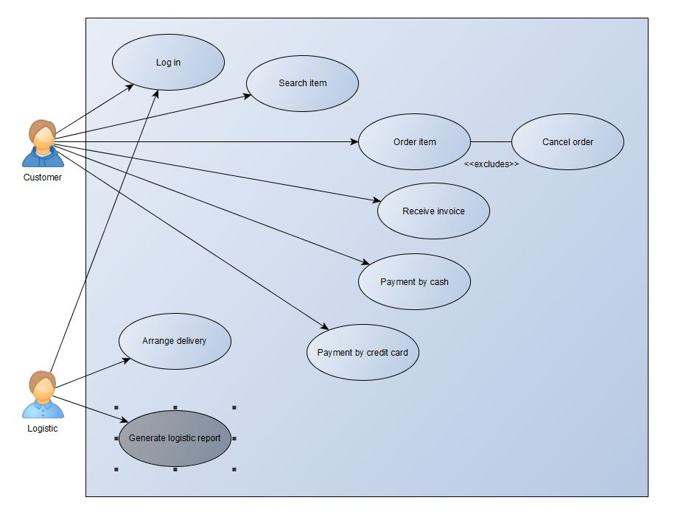

**3.3 Use Case Full Description**

|  |  |  |
| --- | --- | --- |
| Use case name: | Log In | |
| Scenario: | Customer logs in his/her account | |
| Triggering Events: | Customer enter his/her username and password to log in to the system . | |
| Brief Description: | When customer log in to the system to view available items. | |
| Actor/s: | Customer | |
| Related Use case: | Search item | |
| Stakeholders: | Logistics: to validate account | |
| Pre-conditions: | Customer must have an account | |
| Post-conditions: | Customer has an access to the system | |
| Flow of Events: | Actor   1. Customer enters his/her username and password to log in to the system. 2. Customer can view the items. | System   1. Display the homepage of the system |
| Exception Conditions: | Customer does not have an account  Customer account is invalid | |

|  |  |  |
| --- | --- | --- |
| Use case name: | Search Item | |
| Scenario: | Customer searches an item | |
| Triggering Events: | To search item | |
| Brief Description: | Customer enters the system to search for an item | |
| Actor/s: | Customer | |
| Related Use case: | Log In | |
| Stakeholders: | Supplier: to provide a list of all items available | |
| Pre-conditions: | Customer must have an account | |
| Post-conditions: | Availability and the price of the product | |
| Flow of Events: | Actor  1. Customer enters to the system.  2. Customer browses the system to search for an item. | System   * 1. Display the details of the a specific item   2. Display if the item is available |
| Exception Conditions: | There is no item | |

|  |  |  |
| --- | --- | --- |
| Use case name: | Order item | |
| Scenario: | Customer order an item | |
| Triggering Events: | To order item | |
| Brief Description: | Customer order an item | |
| Actor/s: | Customer, | |
| Related Use case: | Inquires item availability | |
| Stakeholders: | Customer, Supplier | |
| Pre-conditions: | Customer pick an item he wants to order | |
| Post-conditions: | Order details | |
| Flow of Events: | Actor  1.) Customer orders an item  2.) Customer can browse another item | System  2.) System display the order details |
| Exception Conditions: | No customer | |

|  |  |  |
| --- | --- | --- |
| Use case name: | Cancel order | |
| Scenario: | Customer cancel an order | |
| Triggering Events: | To cancel order | |
| Brief Description: | Customer will cancel an order | |
| Actor/s: | Customer | |
| Related Use case: | Inquires item availability | |
| Stakeholders: | Customer | |
| Pre-conditions: | Customer had an item ordered | |
| Post-conditions: | Cancellation of order | |
| Flow of Events: | Actor  1.) Customer cancel his/her order  2.) Customer can search and order an item | System   1. The system will cancel the order. 2. The system will display the items |
| Exception Conditions: | There is no order to cancel | |

|  |  |  |
| --- | --- | --- |
| Use case name: | Receive invoice | |
| Scenario: | After ordering an item the customer will receive an invoice | |
| Triggering Events: | To receive invoice bill | |
| Brief Description: | Customer will cancel an order | |
| Actor/s: | Customer | |
| Related Use case: | Log in, Search item, Order item, Cancel item | |
| Stakeholders: | Customer | |
| Pre-conditions: | Customer had an item ordered | |
| Post-conditions: | Cancellation of order | |
| Flow of Events: | Actor  1.) Customer will received an invoice after ordering an item | System   1. The system will display the invoice bill. 2. The system will ask the customer what will be his payment method |
| Exception Conditions: | There is no order | |

* 1. **Functional Decomposition Diagram**

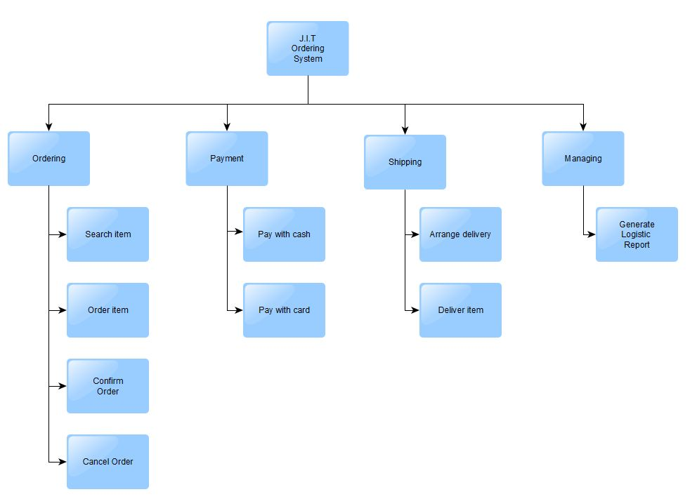

**3.5 Context Flow Diagram**

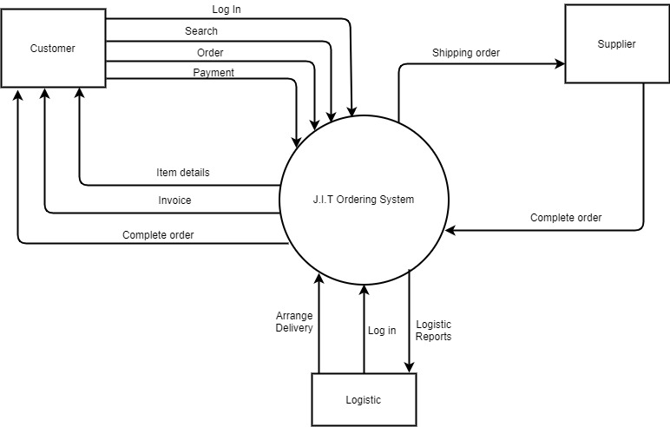

**3.6 Data Flow Diagram Level 0**

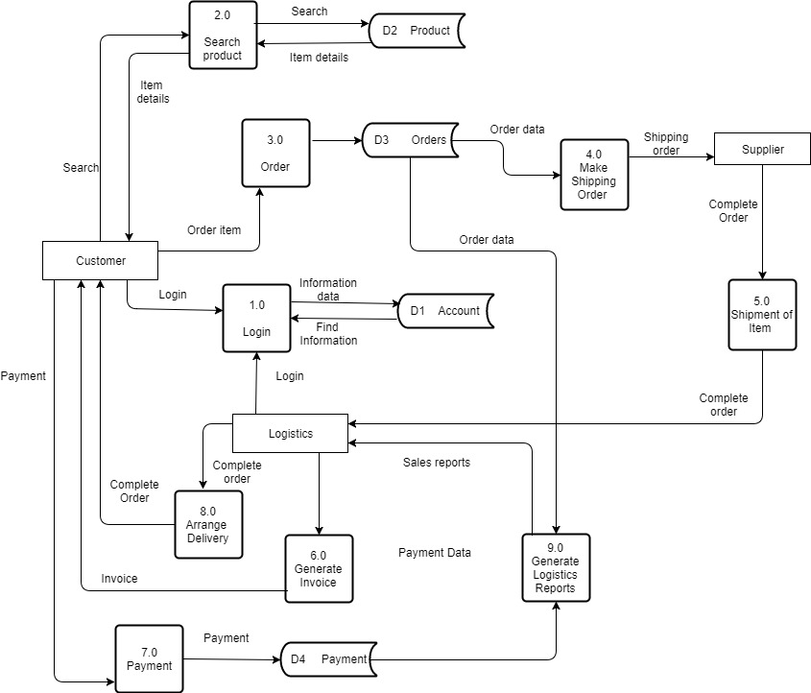

**3.7 Activity Diagram**

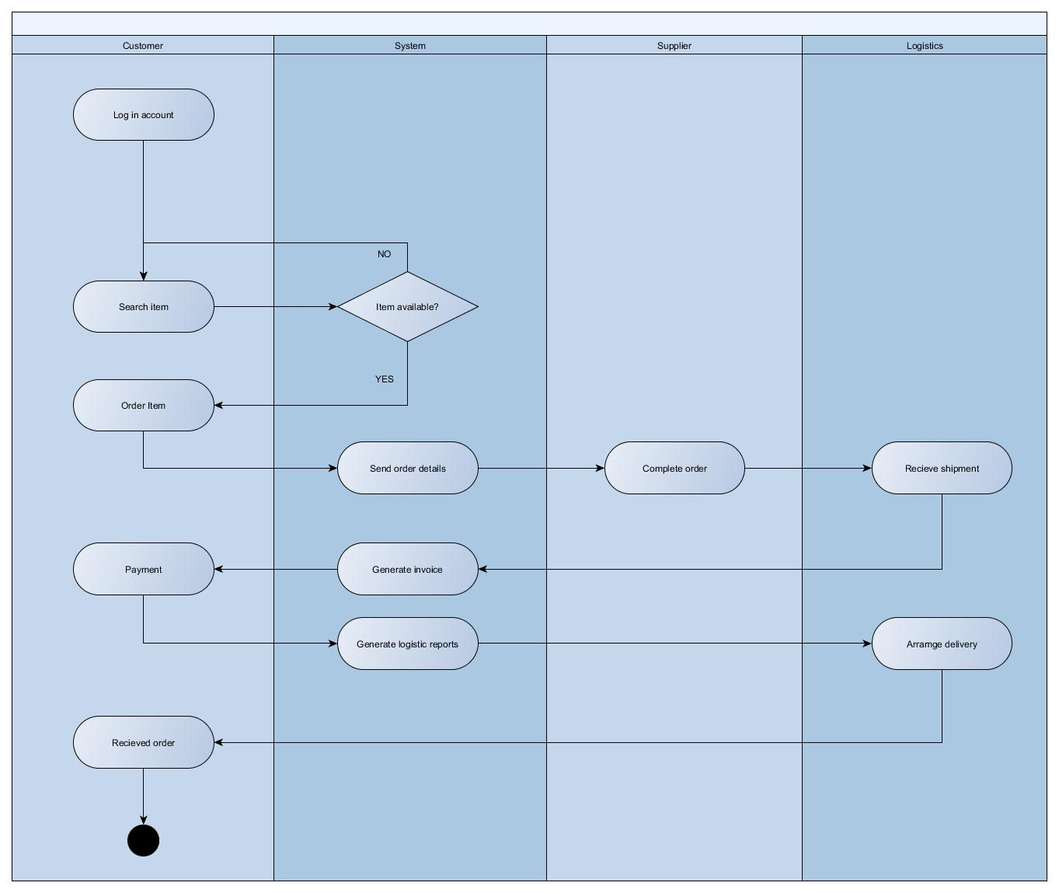

**3.8 Sequence Diagram**

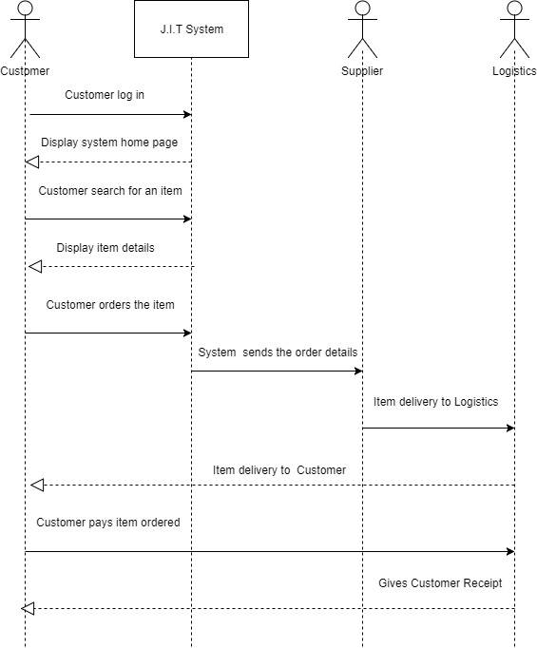

**3.9 Entity Relationship Diagram**

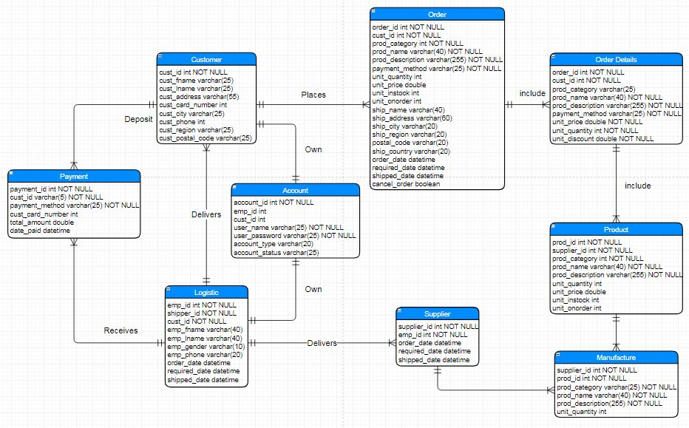

**CUSTOMER TABLE**

|  |  |  |  |
| --- | --- | --- | --- |
| P/F | FIELD NAME | DATA TYPE | FIELD SIZE |
| P | CUST_ID | INT |  |
|  | CUST_FNAME | VARCHAR | 25 |
|  | CUST_LNAME | VARCHAR | 25 |
|  | CUST_ADDRESS | VARCHAR | 55 |
|  | CUST_CARD­_NUMBER | INT |  |
|  | CUST_CITY | VARCHAR | 25 |
|  | CUST_PHONE | INT |  |
|  | CUST_REGION | VARCHAR | 25 |
|  | CUST_POSTAL_CODE | VARCHAR | 25 |
|  | CUST_PHONE | INT |  |

**CUSTOMER ORDER TABLE**

|  |  |  |  |
| --- | --- | --- | --- |
| P/F | FIELD NAME | DATA TYPE | FIELD SIZE |
| P | ORDER_ID | INT |  |
| F | CUST_ID | INT |  |
|  | PROD_CATEGORY | VARCHAR | 25 |
|  | PROD_NAME | VARCHAR | 40 |
|  | PROD_DESCRIPTION | VARCHAR | 255 |
|  | PAYMENT_METHOD | VARCHAR | 25 |
|  | UNIT_QUANTITY | INT |  |
|  | UNIT_PRICE | DOUBLE |  |
|  | UNIT_INSTOCK | INT |  |
|  | UNIT_ONORDER | INT |  |
|  | SHIP_NAME | VARCHAR | 40 |
|  | SHIP_ADDRESS | VARCHAR | 60 |
|  | SHIP_CITY | VARCHAR | 20 |
|  | SHIP_REGION | VARCHAR | 20 |
|  | POSTAL_CODE | VARCHAR | 20 |
|  | SHIP_COUNTRY | VARCHAR | 20 |
|  | ORDER_DATE | DATETIME |  |
|  | REQUIRED_DATE | DATETIME |  |
|  | SHIPPED_DATE | DATETIME |  |
|  | CANCEL_ORDER | BOOLEAN |  |

**CUSTOMER ORDER DETAILS**

|  |  |  |  |
| --- | --- | --- | --- |
| P/F | FIELD NAME | DATA TYPE | FIELD SIZE |
| F | ORDER ID | INT |  |
| F | CUST_ID | INT |  |
|  | PROD_CATEGORY | VARCHAR | 25 |
|  | PROD_NAME | VARCHAR | 40 |
|  | PROD_DESCRIPTION | VARCHAR | 255 |
|  | PAYMENT_METHOD | VARCHAR | 25 |
|  | UNIT_PRICE | DOUBLE |  |
|  | UNIT_QUANTITY | INT |  |
|  | UNIT_DISCOUNT | DOUBLE |  |

**LOGISTIC TABLE**

|  |  |  |  |
| --- | --- | --- | --- |
| P/F | FIELD NAME | DATA TYPE | FIELD SIZE |
| P | EMP_ID | INT |  |
| F | SHIPPER_ID | INT |  |
| F | CUST_ID | INT |  |
|  | EMP_FNAME | VARCHAR | 40 |
|  | EMP_LNAME | VARCHAR | 40 |
|  | EMP_GENDER | VARCHAR | 10 |
|  | EMP_PHONE | VARCHAR | 20 |
|  | EMP_EMAIL | VARCHAR | 20 |
|  | ORDER_DATE | DATETIME |  |
|  | REQUIRED_DATE | DATETIME |  |
|  | SHIPPED_DATE | DATETIME |  |

**SUPPLIER**

|  |  |  |  |
| --- | --- | --- | --- |
| P/F | FIELD NAME | DATA TYPE | FIELD SIZE |
| P | SUPPLIER_ID | INT |  |
| F | EMP_ID | INT |  |
|  | ORDER_DATE | DATETIME |  |
|  | REQUIRED_DATE | DATETIME |  |
|  | SHIPPED_DATE | DATETIME |  |

**PRODUCT TABLE**

|  |  |  |  |
| --- | --- | --- | --- |
| P/F | FIELD NAME | DATA TYPE | FIELD SIZE |
| P | PROD_ID | INT |  |
| F | SUPPLIER_ID | INT |  |
|  | PROD_CATEGORY | INT |  |
|  | PROD_NAME | VARCHAR | 40 |
|  | PROD_DESCRIPTION | VARCHAR | 255 |
|  | UNIT_QUANTITY | INT |  |
|  | UNIT_PRICE | DOUBLE |  |
|  | UNIT_INSTOCK | INT |  |
|  | UNIT_ONORDER | INT |  |

**MANUFACTURE**

|  |  |  |  |
| --- | --- | --- | --- |
| P/F | FIELD NAME | DATA TYPE | FIELD SIZE |
| F | SUPPLIER_ID | INT |  |
| F | PROD_ID | INT |  |
|  | PROD_CATEGORY | VARCHAR | 25 |
|  | PROD_NAME | VARCHAR | 40 |
|  | PROD_DESCRIPTION | VARCHAR | 255 |
|  | UNIT_QUANTITY | INT |  |

**PAYMENT**

|  |  |  |  |
| --- | --- | --- | --- |
| P/F | FIELD NAME | DATA TYPE | FIELD SIZE |
| P | PAYMENT_ID | INT |  |
| F | CUST_ID | INT | 5 |
|  | PAYMENT_METHOD | VARCHAR | 25 |
|  | CUST_CARD_NUMBER | INT |  |
|  | TOTAL_AMOUNT | DOUBLE |  |
|  | DATE_PAID | DATETIME |  |

**ACCOUNT**

|  |  |  |  |
| --- | --- | --- | --- |
| P/F | FIELD NAME | DATA TYPE | FIELD |
| P | ACCOUNT_ID | INT |  |
| F | EMP_ID | INT |  |
| F | CUST_ID | INT |  |
|  | USER_NAME | VARCHAR | 25 |
|  | USER_PASSWORD | VARCHAR | 25 |
|  | ACCOUNT_TYPE | VARCHAR | 25 |
|  | ACCOUNT_STATUS | VARCHAR | 25 |